Last update: Dec. 17, 2020

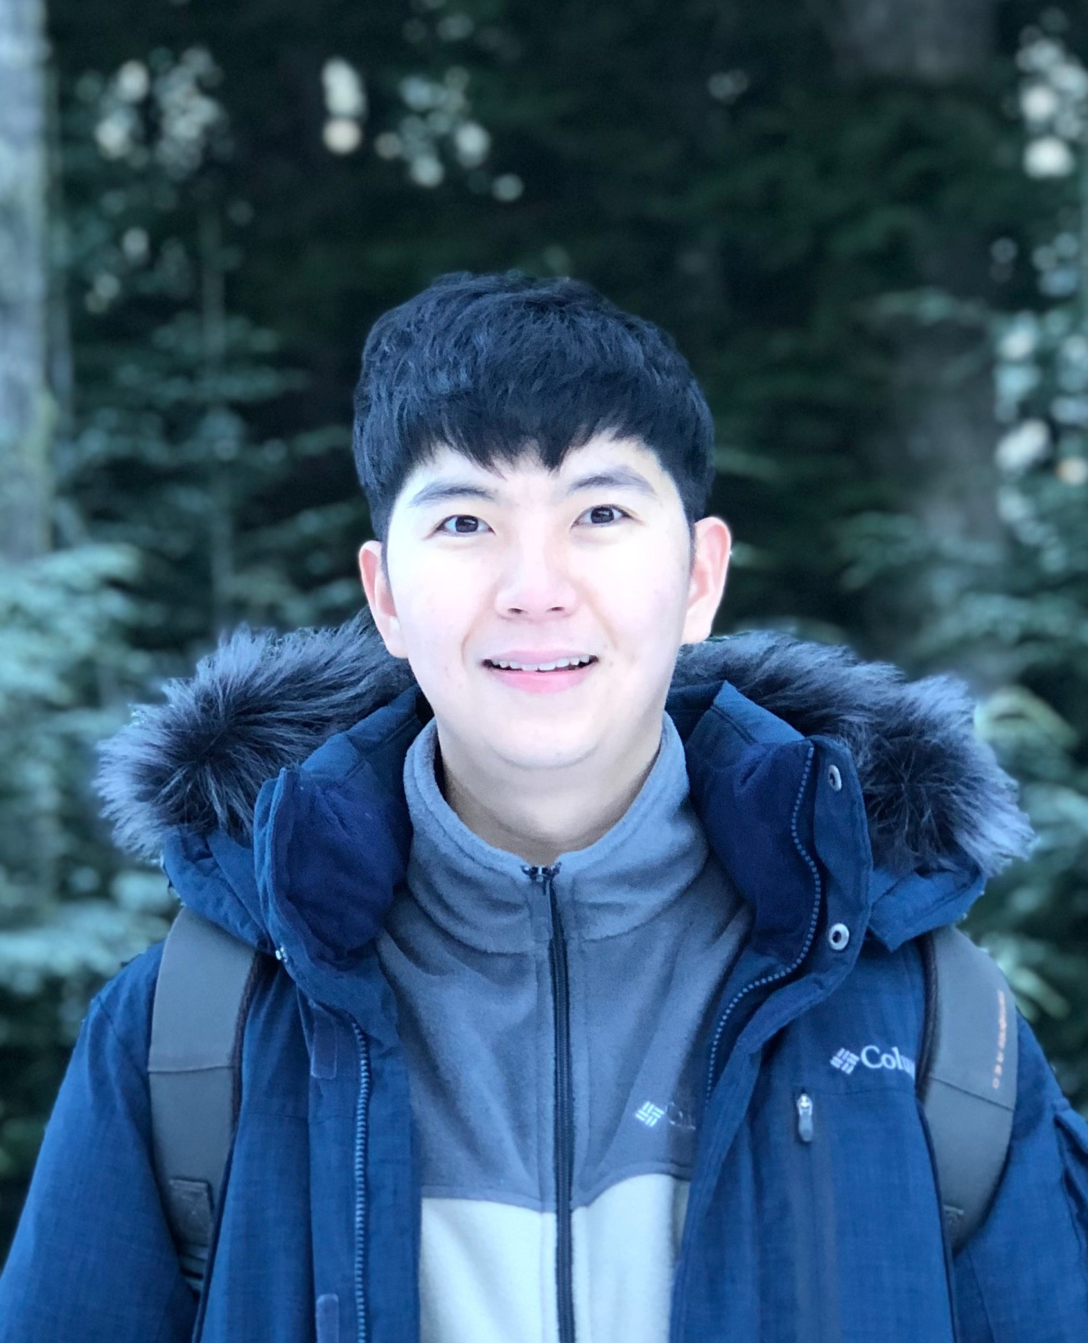**Yeonuk Kim, PhD Candidate**

Institute for Resources, Environment and Sustainability,

University of British Columbia (UBC) [2017 – present]

411-2202 Main Mall, Vancouver, BC, V6T 1Z4

# ORCID: orcid.org/0000-0003-2993-8687

# <https://www.researchgate.net/profile/Yeonuk_Kim2>

# Researcher ID: ABC-2175-2020; https://publons.com/researcher/3977574/yeonuk-kim/

# Education and professional experience

***Education:***

Ph. D. Candidate, University of British Columbia, Canada. [2017 – present]

Fast-track transfer from MSc. to PhD, University of British Columbia, Canada. [2018]

BSc., Rural Systems Engineering (*Cum laude*), Seoul National University, South Korea. [2016]

***Professional experience:***

Graduate Research Assistant, University of British Columbia (PI: Dr. Mark Johnson) [2017 – present]

Researcher, National Center for Agro-Meteorology, South Korea [2016]

Undergraduate Research Assistant, Seoul National University (PI: Dr. Joon Kim) [2014 – 2015]

# Brief Bio

Kim graduated Seoul National University (SNU). He was awarded numerous merit-based scholarships along the way to earning the Grand Prize for undergraduate research from SNU. As an undergraduate, Kim led a biometeorological study resulting in a publication in *Agriculture, Ecosystems & Environment*. He worked at the National Center for Agro-Meteorology in Korea, where he managed eddy-covariance systems.

Upon joining UBC MSc program, Kim assumed the day-to-day operation of an eddy covariance flux tower system in Burns Bog near Vancouver, meeting regularly with researchers and technicians from three separate departments. In the process, he developed several new approaches to working with methane flux data. He then convened an international effort to apply these approaches to flux data from other sites, resulting in a paper that he led that was published in *Global Change Biolog*y.

After transfer from MSc to PhD program, Kim has been working on evapotranspiration theory and modelling. In this process, he was awarded a Mitacs Globalink internship, spending three months in Dr. Monica Garcia’ lab in the Technical University of Denmark during 2019. He was also an invited participant to the 2019 AmeriFlux Early Career Workshop, and was selected to participate in the US National Center for Atmospheric Research (NCAR) training course on the Community Land Model. Kim’s policy brief on water management in Korea presenting strategies to reduce water use for rice field irrigation won an idea contest for sustainable water management from the *Korea Water Resources Corporation.*

Kim’s research focus on: (1) evapotranspiration theory (both physical and physiological) and its

applications, (2) micrometeorological measurements of turbulent heat and water vapour fluxes, (3)

evapotranspiration and drought modelling through satellite remote sensing, (4) land surface and climate modelling. (5) machine-learning applications to earth systems science.

# Honors and Awards

Graduate program

2019. Mitacs Globallink Research Award. Mitacs

2018 – 2022. Four Years Doctoral Fellowships. UBC

2017 – 2022. International Tuition Award. UBC

2017 – 2018. Faculty of Science Graduate Award. UBC

2018. Award by President of Korea Water Resources Corporation. Idea contest for sustainable water management in South Korea

Undergraduate program

2017. Excellent Degree Thesis Award. College of Agriculture and Life Science, SNU

2015. Grand Prize (Award by President of SNU). SNU Undergraduate Research Award, SNU

2015. Evergreen Scholarship. SNU Evergreen Scholarship Foundation

2014 – 2015. Agricultural Engineering Scholarship. SNU Alumni Association of Agricultural Engineering

2011, 2014-2015. Merit Based Scholarship (Scholarship of Superior Academic Performance). SNU

2009. National Scholarship for Science and Engineering. Korea Student Aid Foundation

# Courses Taught

Module developer and delivery. Ecohydrology of Watersheds and Water Systems (ENVR 420, UBC), Guest lecture topic: Evapotranspiration theory and applications [2019]

Teaching Assistant*.* Ecohydrology of Watersheds and Water Systems (ENVR 420, UBC) [2018]

Teaching Assistant*.* Land, Food and Community 1 (LFS 250, UBC) [2017 – 2018]

# Current research project

Improving Estimates of Evapotranspiration and Land Surface Relative Humidity Using Satellite-Derived Soil Moisture and Vegetation Optical Depth from SMAP-SMOS and Land Surface Temperature from Sentinel-3, *Canadian Space Agency*. **Co-I** [under review]

Agricultural Water Innovation in the Tropics, [Water JPI 2016 Joint Call for Transnational Collaborative Research Projects](http://www.waterjpi.eu/index.php?option=com_content&view=article&id=440&Itemid=1008), *Natural Sciences and Engineering Research Council of Canada.* **RA** [2017 – 2020]

**Selected Publications**

* H-index: 3, Total citations: 45 (Google Scholar)

1. **Kim, Y.**, Garcia, M., Black, T. A. & Johnson, M. S. General equilibrium evaporation. [In preparation]*.*
2. **Kim, Y.**, Morillas, L., Garcia, M., Weber, U., Black, T. A. & Johnson, M. S. (2020). Relative humidity gradients as a key constraint on terrestrial water and energy fluxes. *Hydrology and Earth System Sicences Discussion.* [preprint]. doi:10.5194/hess-2020-643
3. **Kim, Y.**, Johnson, M. S., Knox, S., Black, T. A., Dalmagro, H. J., Kang, M., Kim, J. & Baldocchi, D. (2020). Gap-filling approaches for eddy covariance methane flux: a comparison of three machine learning algorithms and a traditional method with and without principal component analysis. *Global Change Biology.* 26 (3), 1499-1518. doi:10.1111/gcb.14845.
4. **Kim, Y.**, Talucder, M. S. A., Kang, M., Shim, K. -M., Kang, N. & Kim, J. (2016). Interannual variations in methane emission from an irrigated rice paddy caused by rainfall during the aeration period. *Agriculture, Ecosystems & Environment.* 223, 67-75.
5. Choi, S.W., Kim, H., **Kim, Y.**, Kang, M. & Kim, J. (2016). Estimation and mapping of methane emission from rice paddies in Gyunggi-do using the modified water management scaling factor. *Korean Journal of Agricultural and Forest Meteorology.* 18(4), 320-326

**Selected Presentation and Posters**

1. **Kim, Y.**, Johnson, M. S., Knox, S., Black, T. A., Dalmagro, H. J., Kang, M., Kim, J., Ryu, Y., Baldocchi, D. (2019). CH4 flux gap-filling approaches for eddy covariance data: a comparison of three machine learning algorithms and marginal distribution sampling method with and without principal component analysis*. 2019 EGU General Assembly.* Vienna, Austria (Poster)
2. **Kim, Y.** & Johnson, M. S. (2017). Spectral entropy as a mean to quantify water stress history for natural vegetation and irrigated agriculture in a water-stressed tropical environment. *2017 AGU Fall Meeting.* New Orleans, Louisiana, USA (Poster)
3. Johnson, M. S., Lathuilliere, M. J., Morillas, L., Dalmagro, H. J., D’Acunha, B., **Kim, Y.**, Suarez, A. & Couto, E. G. (2017). Carbon and water fluxes and footprints in tropical agricultural systems under rainfed and irrigated conditions. *2017 AGU Fall Meeting.* New Orleans, Louisiana, USA (invited)
4. Choi, S.W., Kang, M., Indrawati, Y.M., Kim, H., **Kim, Y.** & Kim, J. (2016). Carbon footprint estimation using long-term flux measurement in Haenam, Korea: Implication for climate-smart agriculture. *EcoSummit 2016.* Le Corum, Montpellier, France (Poster)
5. **Kim, Y.**, Talucder, M. S. A., Kang, M., Kang, N., Shim, K. -M. & Kim, J. (2015). Changes in methane emission from rice paddy triggered by rainfall during the mid-season Drainage (in Korean). *The 2015 Korean Meteorological Society Fall Conf.* Jeju, Korea (Oral)

**Workshop and other activities**

2019. Visiting PhD student (three months). Dr. Monica Garcia’s group at Technical University of Denmark

2019. Invited workshop participant. 2019 AmeriFlux Early Career Workshop, Boulder, CO, USA

2019. Workshop participant. CLM (Community Land Model) / CTSM (Community Terrestrial Systems Model) tutorial, National Center for Atmospheric Research (NCAR) Mesa Lab, Boulder, CO, USA

2016. Workshop participant. The International Workshop on Agromet and GIS Applications for Agricultural

Decision Making (AgMP, WMO), Jeju, South Korea